History


Items highlighted in yellow are tasks for you to complete
Items in Blue italics are help tips

Death of James Cook
This is a more accurate reconstruction of the moment than depicted in earlier paintings. It is based on the eye witness account of Marine Lt. Molesworth Phillips, a study of the weapons and dress of both sides, and estimates by scientists of the physical setting. Cook was not in breeches and hose, but wearing canvas trousers. He was not on a sandy beach, but was struck down while striding toward the water across a broad lava rock, his spent musket in his right hand.
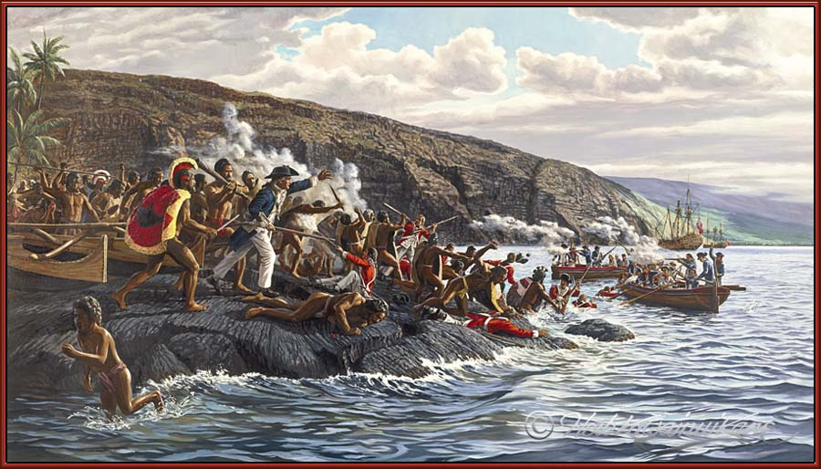
This work also includes the first depiction of Hawaiian battle mats, described in British journals as worn in the same manner as the feather capes. In combat the cape was carried over the left shoulder and held forward by the left hand to take the impact of a sling stone or to snag the point of a spear or dagger, leaving the right arm free to wield a weapon.

Geologists believe this coastline has subsided 28 inches in the last 200 years. The rock from which Cook fell is now submerged, but can be located. The waterline on the rock is the result of computer work with moon phases which produced an estimate of the tide at 8:00 AM.

Cook had abandoned his attempt to take the king hostage against the return of a stolen boat. At a threatening gesture by one of the king's guards, he fired both barrels of his musket, then ordered the marines to fire. Instead of dispersing, the Hawaiians charged. Phillips heard Cook shout, "Take to the boats!" Phillips was struck down and stabbed in the shoulder, but raised himself and fired at his assailant before escaping. A man with a crude club struck Cook behind the head, while a chief in a feather cape, known to the British as Nua, rushed around a parked double canoe and stabbed him with one of the iron daggers the ship's blacksmiths had been forging as trade items. Surgeon's Mate Samwell described Nua as a of "... great consequence ... tall and stout and one who united in his figure the two qualities of strength and agility in a greater degree, than I ever remembered to have seen before in any other man." Cook fell face down in the water and was stabbed many times.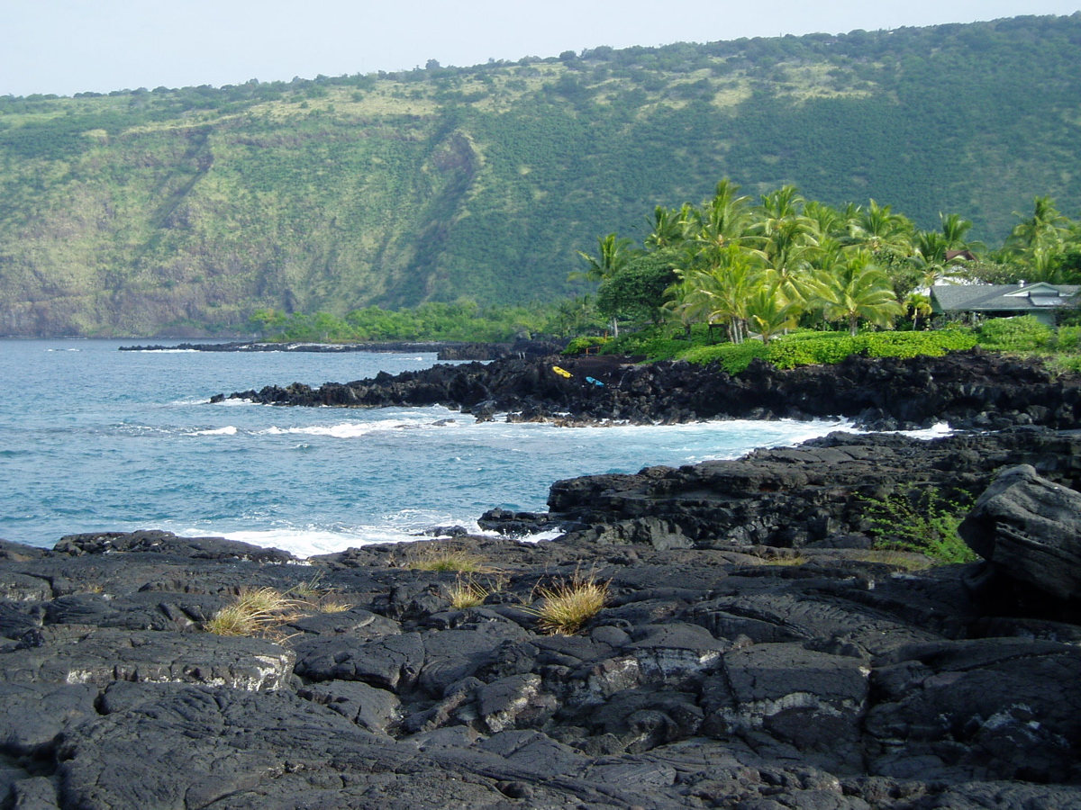

At the far left, the old king is being escorted to safety. Marine corporal, James Thomas, waist deep in the water, receives a mortal wound from a dagger thrust. Resolution is shown with the foremast removed for repair. Cook's hand was raised toward the boats -- a gesture now widely interpreted as a signal to cease firing. However, J.C. Beaglehole, the most eminent of Cook scholars, believed Cook was waving to the boats to come closer to shore. Like so many mariners of his day, he could not swim.

Painting by the late Herb Kane R.I.P
June 21, 1928
March 8, 2011

"If my work contributes to our comprehension of Hawaii's past, that will ultimately become the greatest reward."
-Herb Kawainui Kane

In 1768 King George III of England orders an ambitious expedition to the Pacific Ocean to observe the transit of Venus and to see the mythical Southern Continent. James Cook, an unknown petty officer, is controversially appointed as commander, choosing an unlikely collier to carry him and his men into dangerous and unknown waters. After sailing to Tahiti, where the eclipse proves disappointing, Cook proceeds to chart the coasts of New Zealand, various Pacific islands and Australia beginning a glorious adventure spanning the oceans of the world.

Captain James Cook

Need help just ask

